Highly motivated and established actor, producer, and director. Lead many exceptional works in theater, television, and cinema. A member of the board and consultant to the Syndicate of Lebanese Actors since 2010.

|  |  |
| --- | --- |
| PROFESSIONAL  ACHIEVEMENTS | **TELEVISION SERIES:**  Over 60 television series, some of which are: |

الحرملك ج 1-ج2

FAYSAL ELESTWANI

OBJECTIVE

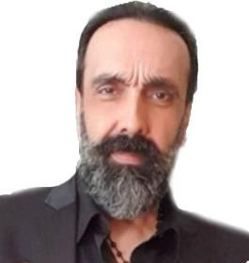

خمسة و نص

لا حكم عليه خرزة زرقا

بعد حين

بلحظة

كواليس المدينة

الوحش

حدود شقيقة

رماد وملح

راحو

بالدم

**THEATER:**

Over 30 children, tragedy, musical, and comedy plays, some of which are:

الجيب السري هريبة يا اوادم

القمر بيضوي عالناس

علاء الدين المارد

**PRODUCTION AND DIRECTING:**

Executive producer and assistant director for multiple works since 2007

غدا يوم اخر

لانه الحب

دقة قلب

لوما انقطعت الكهربا

اخر الليل

صحن يومي

االوحش

**International Festivals**

مهرجــــان قرطــــاج المســـرحــي **– تونــــــس**

مهرجـــــان الفــرنكوفــــونـــــية- **فرنسا**

مهرجــــان القاهرة للمســـرحــي التجريبي –**مصر**

|  |  |  |
| --- | --- | --- |
|  | | **DIRECTING**  تصوير اعلانات  اخراج مشاهد تمثيلية افلام قصيرة للجامعات و المهرجانات  **DUBBING**  Over 2000 hours of dubbing: Drama, Cartoons, Documentaries, and Games |
| SKILLS | Coaching of young actors  Expert level use of Microsoft Office Novice level use of Sound Forge Novice level use of Photoshop | | |
| EDUCATION | **MASTERS OF FINE ARTS IN ACTING – LEBANESE UNIVERSITY - 1993**  Graduation project won first place at the 1993 Cairo International Festival  for Contemporary and Experimental Theatre. | | |

REFERENCES **REFERENCES AVAILABLE UPON REQUEST**

PERSONAL Faysal A. Elestwani

INFORMATION Beirut, Lebanon

Tel: +961-71-500-200 faysal.elestwani@gmail.com

Faysal Elestwani